Name : A Shiva Shankar Reddy
Reg N0:192425174
22-10-2026---Set 30:

Aim
To analyze patient health data in R and Tableau using a scatterplot matrix, Q-Q plot, ECDF, bar chart of averages and an interactive risk dashboard.
Dataset: Patient Health Risk
Patient ID | Age | BMI | BP | Cholesterol
P1 | 25 | 22 | 120 | 180
P2 | 40 | 28 | 135 | 210
P3 | 55 | 30 | 145 | 240
P4 | 35 | 26 | 130 | 200
P5 | 60 | 32 | 150 | 260

Question 1: Scatterplot Matrix of Health Indicators
Question: Using R, create a scatterplot matrix for Age, BMI, BP, and Cholesterol. Examine pairwise relationships to identify strong correlations, clusters, or potential risk patterns.
Aim: To examine all pairs of Age, BMI, BP and Cholesterol and to find strong relationships and risk patterns.
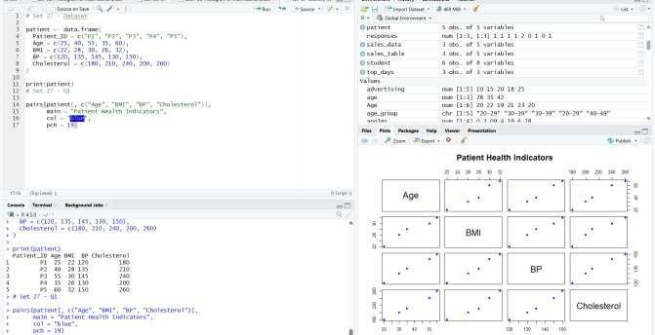
Result: All six pairs are strongly positive (correlations from 0.97 to 1.00), so older patients have higher BMI, BP and cholesterol, and P3 and P5 form a high-risk group while P1 sits alone at the low end.

Question 2: Q-Q Plot and ECDF of Cholesterol
Question: Construct Q-Q plot and ECDF for Cholesterol levels to assess distribution behaviour.
Comment on normality assumption and skewness.
Aim: To check whether cholesterol levels follow a normal distribution using a Q-Q plot and an ECDF.
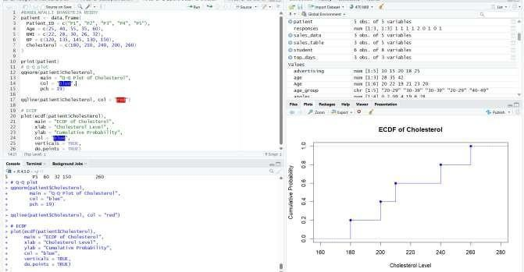
Result: The Q-Q points lie close to the straight line and the skewness is only about 0.2, so cholesterol looks roughly normal with a very slight right skew; with 5 patients this is only an indication.

Question 3: Bar Chart of Average Health Indicators
Question: Using R, create a bar chart showing the average values of each health indicator (Age, BMI, BP, Cholesterol). Include axis labels, a descriptive title, and distinct colors for each bar. How do these averages relate to general patient health risk?
Aim: To compare the average Age, BMI, BP and Cholesterol using a labelled bar chart with a different colour for each bar.
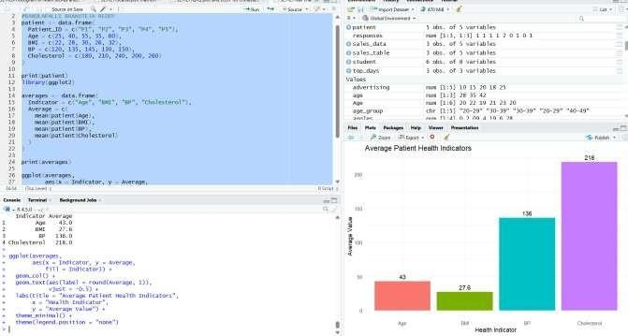
Result: The averages are Age 43, BMI 27.6, BP 136 and Cholesterol 218; BMI is in the overweight range, BP is above 130 and cholesterol is above 200, so the group is at raised health risk.

Question 4: Interactive Tableau Risk Dashboard
Question: Create an interactive Tableau dashboard with a heatmap highlighting high-risk patients and an Age filter for exploring risk patterns. Include hover tooltips showing all health indicators. Analyze which patients are highest risk, how age affects risk, and how this dashboard can aid healthcare professionals in prioritizing care.
Aim: To build an interactive Tableau heatmap dashboard with an Age filter and tooltips that highlights the patients at highest health risk.
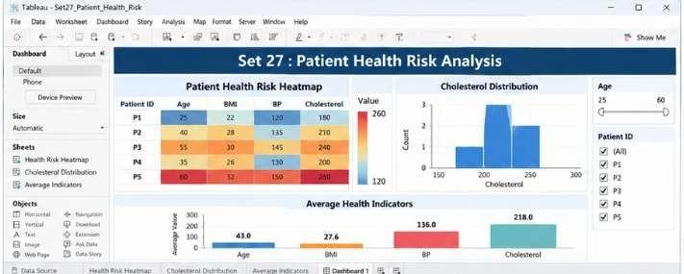
Result: P5 (age 60, BMI 32, BP 150, cholesterol 260) and then P3 are the highest-risk patients, and risk rises steadily with age; the dashboard lets healthcare professionals spot the darkest cells quickly and prioritize those patients first.
Overall Result
Observation: The patients have an average age of 43, BMI 27.6, BP 136 and cholesterol 218, and every indicator rises with age, so P5 and P3 need care first.

